Arabic Language Basics

Section: L01

Assignment Date: 1/09/2021

Name: Talha Abdullah Punjabi

QUID: 201903446

Unit 4 (Drill-9)

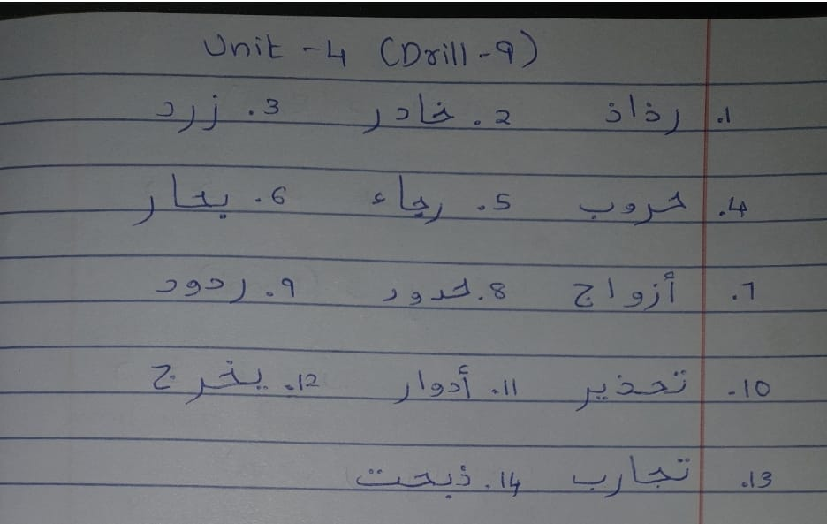

Unit 5 (Drill-3)

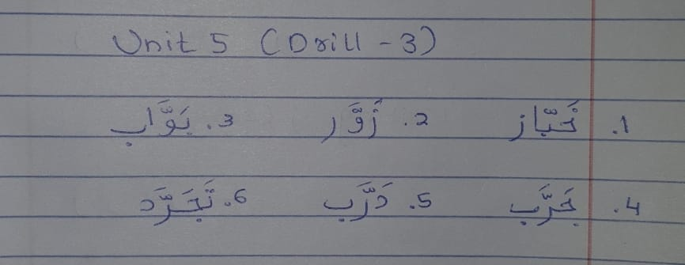

Writing Styles of new letters

